**Data Analysis Report (GYM Membership Data)**  
**Prepared by:** Manas Borse  
**Date:** 09-03-2025

## **1. Introduction**

This report presents the analysis of gym_membership, focusing on key insights derived from the data. The dataset was analyzed using **Python (Pandas, Matplotlib, NumPy)**. The Data was Visualized in Python Compiler Named **Jupyter Notebook**.

**OBJECTIVE:**

**1.Understanding Gym Usage Patterns Throughout the Day/Week.**

**2.Analysis of Abonoment Type and Usage According to it.**

**3. How does Personal Training effects gym behavior?**

**4. How does Group lessons and activities effects gym behavior?**

## **2. Methodology**

**Dataset Details:**

* Source: [gym_membership_kaggle.com](https://www.kaggle.com/datasets/ka66ledata/gym-membership-dataset)
* Python file: [Click here](https://github.com/Manasborse7125/gym_analysis.git)
* Number of Records: 1000
* Number of Features: 31
* Data Types: [Character,Numerical,Bollean]

**Tools & Techniques Used:**

* Python (Pandas, NumPy, Matplotlib) for data processing and visualization.
* Exploratory Data Analysis (EDA) techniques to clean and preprocess data.

## **3. Data Cleaning & Processing**

* 95% of data provided was Cleaned NO Data Cleaning Methods were implemented.
* Some Data was transformed from String into Numeric which include Birthdate Year.

## **4. Analysis & Findings**

**OBJECTIVE 1: Understanding Gym Usage Patterns Throughout the Day/Week.**

Analysis No 1: As per the analysis it was observed that the **average time of people to work out in gym is 1 hr. 45 min that is around 105 minutes**. Also, it was observed that i**n time of most of the people in Gym was 10 AM** and **out time of the people was 12 AM.** It May be because of people **Prefer gym mostly in morning** comparative to other time.

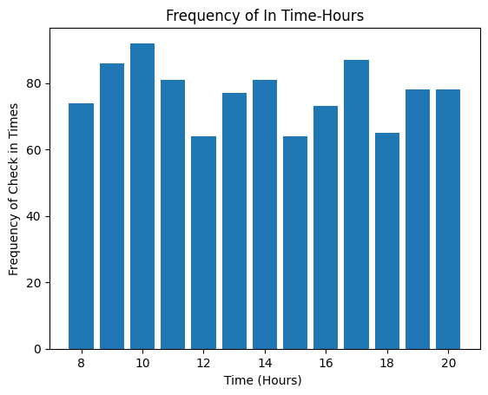 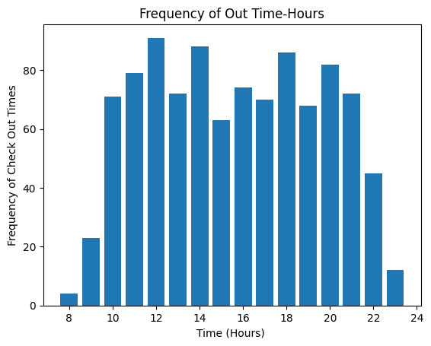It was also observed that the average duration of people the workout is either **50-70 minutes or 130-170 minutes.**

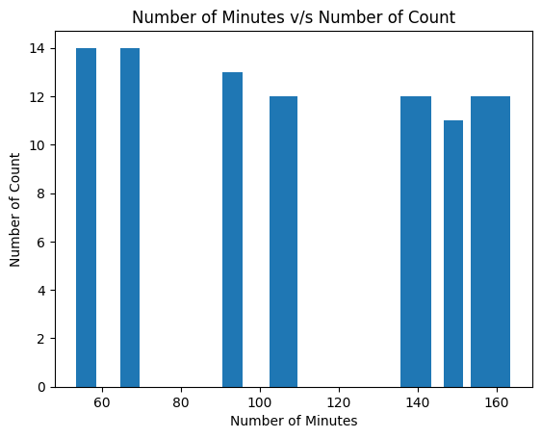

Analysis No 2: While our analysis it was also observed that people **workout mostly on Wednesday** compared to other days the reason behind this would be that **People often feel sluggish by Wednesday and hit the gym to regain energy.**

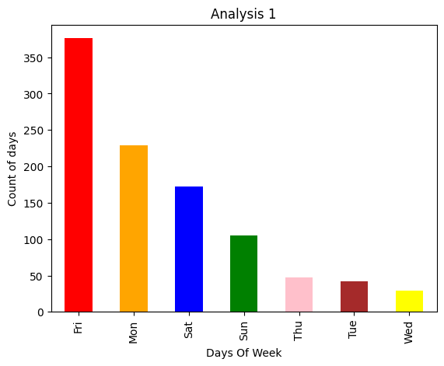 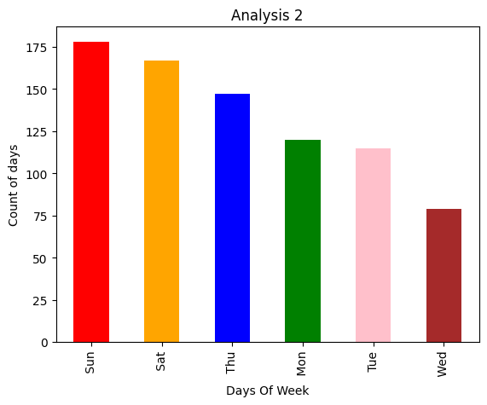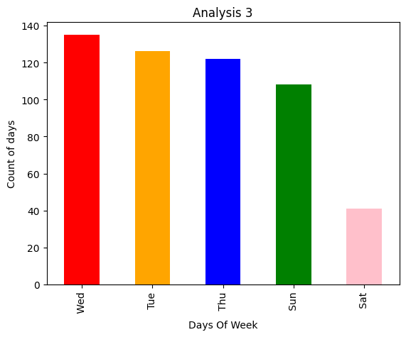 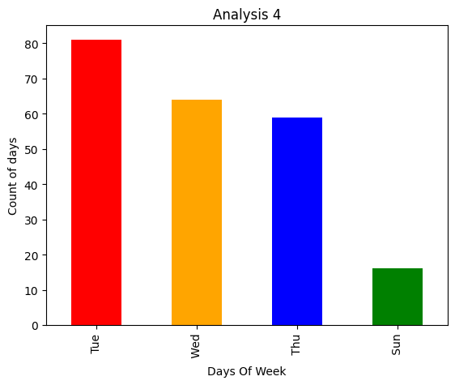

### 

Analysis No 3:

It was observed that most people train themselves 3 days a week and the most repeated day is Wednesday.

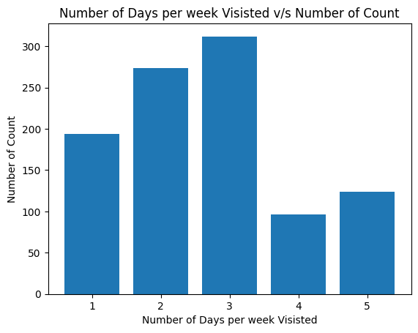

**OBJECTIVE 2: Analysis of Abonoment Type and Usage According to it.**

Analysis No 1: Slightly **more people are preferring Standard Subscription** of gym compared to Premium one. Though the number is not a great difference **Standard 507** and **Premium 493.**

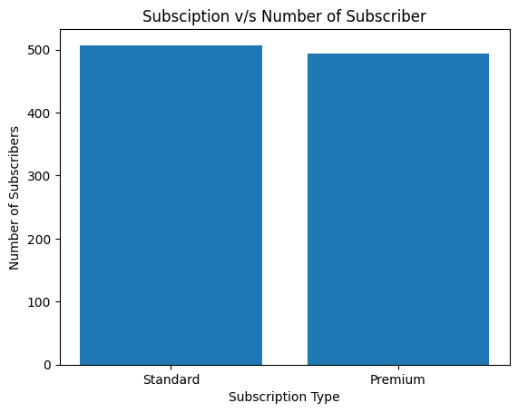

Analysis No 2:

According to the Analyzed data it was seen that:

1.**Male Prefer More Premium Subscription** Compared to Male.

2.**Female Prefer More Standard Subscription** Compared to Female.

3.Least Premium Subscription is done by Female.

4.Least Standard Subscription is done by Male.

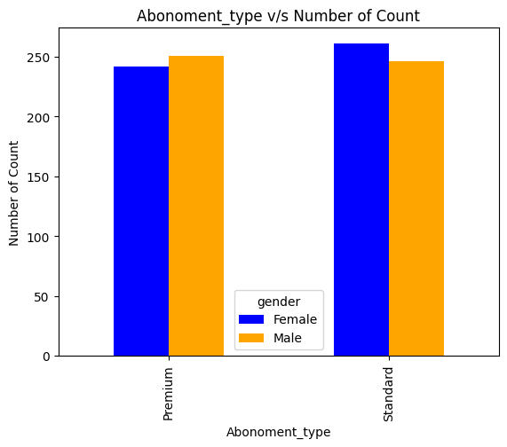

Analysis No 3:

It was observed that the one who has taken **premium Subscription also prefer to appoint personal trainer.**

Almost **267 members** are Subscribed with **Premium Subscription and appointed a personal trainer** to tarin his/her body.

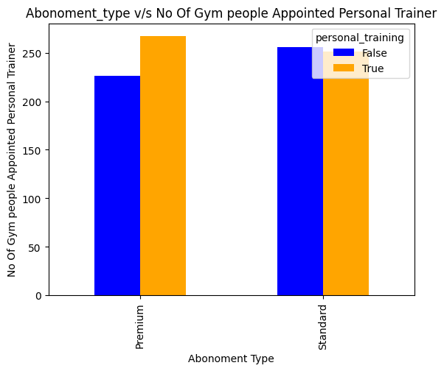

**OBJECTIVE 3: How does Personal Training effects gym behavior?**

Analysis 1:

It was observed that men prefer more personal training then women. Around **270 men’s have appointed personal trainer** for their training in gym.

### 

Analysis 2:

As per the anlysis it has been seen that Most of the premium subscribers of gym has appointed personal trainer, we can conclude thatalmost everyone who takes a premium membership of gym also appoints the personal trainer.

Around 260 members including Male and female has appointed personal trainer in gym.



**OBJECTIVE 4: How does Group lessons and activities effects gym behavior?**

Analysis 1:

According to analysis slightly more men attends group lesson comparatively to women. As per the reports one can conclude that **men are more gym oriented** than women but **women participating is more**.

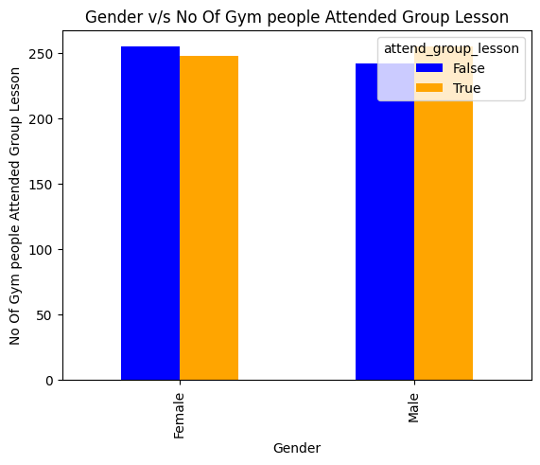

Analysis 2:

Group activities called body pump is most popular in gym. Mostly everyone prefers to make it. The reason behind it could be that it offers a fun, full-body workout with music, group motivation, and efficient strength training.

Whereas the least group activity done by gym people is Zumba with just 81 Attendee. The reason behind this could be that the Zumba is least preferred as it focuses more on dance-based cardio than strength or high-intensity training.

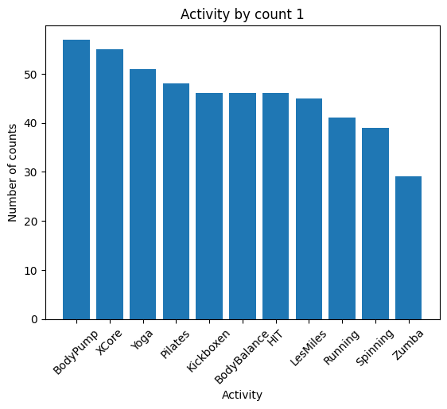 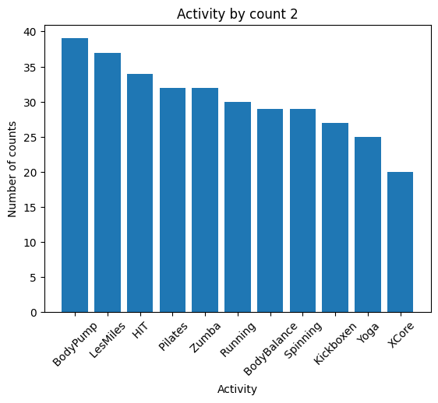 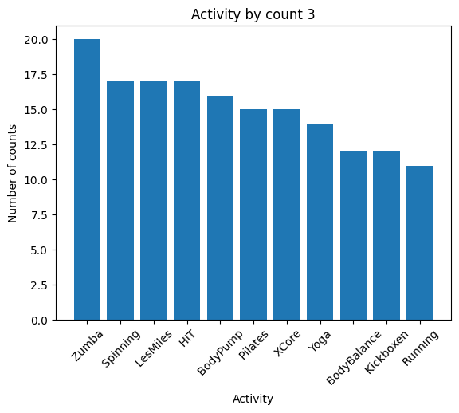

### **5. Conclusion**

* **Peak Workout Time & Duration:** Most gym-goers prefer working out in the morning, with peak hours around 10 AM - 12 PM. The average workout duration is either **50-70 minutes or 130-170 minutes**.
* **Mid-Week Workout Trend:** **Wednesday** sees the highest gym attendance, likely because people feel sluggish mid-week and hit the gym to regain energy. Most members train **3 days a week**, with Wednesday being the most common.
* **Subscription Preferences:** **Standard subscriptions (507) are slightly preferred than Premium (493)**. Males opt for Premium more, while females prefer Standard. Most Premium members also appoint personal trainers (267).
* **Personal Training Influence:** **Men prefer personal training more than women** (270 men hired trainers). Also, nearly all Premium subscribers opt for personal training (around 260 members).
* **Group Activities & Preferences:** **Body Pump is the most popular group activity**, offering a fun, full-body workout with motivation. **Zumba is the least preferred** due to its dance-based cardio focus, which may not appeal to those seeking strength training.

## **6. Recommendations**

* **Extend Peak Hour Facilities:** Increase staff and equipment availability from **10 AM to 12 PM** to accommodate high traffic efficiently.
* **Introduce Mid-Week Specials:** Offer **special workouts or discounts on Wednesdays** to capitalize on the mid-week workout surge.
* **Boost Premium Memberships:** Add **exclusive perks** (e.g., free trial sessions with personal trainers, spa access) to attract more Premium subscribers.
* **Enhance Group Training Engagement:** Introduce **modified Zumba classes** (e.g., Zumba Strength or HIIT-infused Zumba) to attract strength-focused members.
* **Personal Training Incentives:** Offer **discounted personal training for Standard members** to increase trainer engagement and overall membership satisfaction.